

**GATE MONITORING SYSTEM**

**DONE BY**

**SOMANAPALLI DINESH**

**Gate Monitoring System**

**AIM**:

In this project we are developing a welcome message via audio mechanism using a JQ6500 module and greeting to be done as per time instant to the guest and play the thank you message when they are leaving.

**BLOCK DIAGRAM**

16x2 MONOCHROME LCD

RX

AUDIO JQ6500

UART 2

GPIO B

TX

UP_SW

P

O

R

T

C

PORT A

DN_SW

GATE SENSOR

ARM CORTEX M4 NVIC MPU FPU

ENTER_SW

FLASH 128KB

SRAM 64KB

PORTC

IR SENSOR

SW Debugger

I2C-1

SCL

SDA

ST LINK V2 Debugger

RTC

EEPROM

**Hardware Requirement**

1. Raayan Mini

2. Gate sensor (Reed sensor)

3. IR sensor

4. Audio Module JQ6500

5. Speaker

**FLOW CHART:**

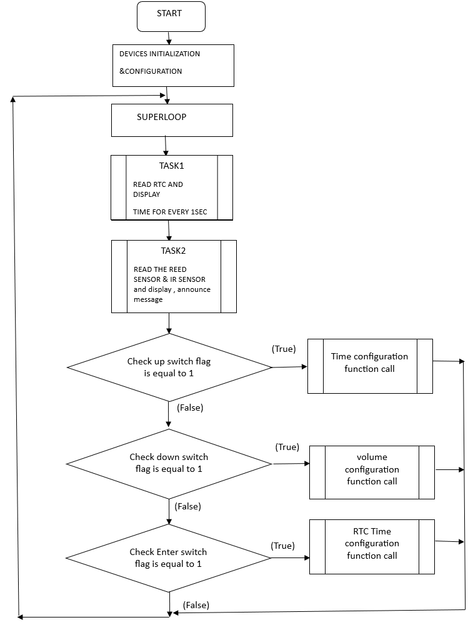

# Main Requirements

The project goals are as follows

1. Use Reed sensor to identify is the gate is open or not.
2. Use the IR Beam sensor to identify if the gate is opened from inside or outside.
3. Play the following audio messages depending on which happens in steps 1 and 2

### Gate opened from outside

- Play greeting audio track depending on time as below

* 1. Track 5 - between 6:00 am and 11:59 am
  2. Track 6 - between 12:00 pm and 4:59 pm
  3. Track 7 - between 5:00 pm and 7:59 pm
  4. Track 8 - between 8:00 pm and 5:59 am

- Then play audio track 1 (“Welcome to India's only Industrial Embedded Systems training institute Kernel Masters, Please leave footwear and bags on the stands provided. Please Close the Gate”) when gate is opened from outside.

### Gate opened from inside

Play audio track 4 (“Thank you for visiting Kernel Masters Please close the Gate”) if gate is opened from inside.

1. After detecting gate has been opened, check periodically if the gate is not closed and play audio track 2 (“Please close the Gate”). Repeat checking gate open/closed condition after the audio track is done playing.

After detecting the gate has been closed, play audio track 3 (“Thank you for closing the Gate”). Then go back to waiting for gate to be opened before starting the above process

. Additional Requirements: • On power up, GMS should display the below on LCD G A T E M O N I T O R I N G V 1 . 0 • Display time on LCD on line 1 and date on line 2 when nothing is happening i.e. gate is closed and no audio tracks are being played.

H H : M M : S S

D D / M M / Y Y

• When gate is opened from outside • Display “Gate Announce…” on LCD line 1 and “Good Morning!”/“Good Afternoon!”/“Good Evening!”/“Good Night!” depending on greeting message on LCD line 2. G A T E A N O U N C E . . . G o o d M o r n i n g ! • When gate is opened from inside • Display “Gate Announce…” on LCD line 1 and “Thank You” on line 2. G A T E A N O U N C E . . . T h a n k Y o u ! 1.5. Configuration Requirements There are two configuration options for this project. • Date and Time configuration o This is meant to be used during power on and is only to be used to set date and time. o After power on and the GMS welcome message is displayed, press the ENTER switch during the 10 second delay to enter in this configuration mode. o After entering this configuration mode, read current date and time from DS1307 RTC and display in below format H H : M M : S S D D / M M / Y Y o The first modifiable field is hours i.e. this is the default modifiable field. If hours have to be changed, press UP or DOWN switch to change hours. Once the desired value is entered for hours, then press enter to finalize that value and move on to the next modifiable field, minutes. o Repeat above step for seconds, date, month and years. o Cursor should be displayed for the current modifiable field in order to avoid confusion. o Note that the chance to modify date and time is possible only once. If any incorrect values are entered, power cycle and repeat above steps. o Note that ENTER switch can be pressed continuously without making any changes to the values and proceed. In this case, there is no need to update date and time in the DS1307 RTC. o Note that if the ENTER switch is not pressed during the 10 second delay after welcome message, proceed forward into gate monitoring functionality. o Note that this will be done as one time function call without any tasks being created. • Volume change o During normal gate monitoring functionality, volume for the audio module JQ6500 can be change at any time. o This is done by pressing UP or DOWN switch to either increase or decrease volume. o Note that you can keep track of the volume range supported on JQ6500 and display the setting on LCD. o Note that the volume setting should not be changed beyond the minimum and maximum values supported by the audio module. Once the range is passed, you can use the buzzer to provide audio feedback. o Note that this should be implemented in a task, separate from the tasks that implement the functionality.

**1. Introduction to Raayan Mini Board**

**1.1. Board Overview**

The STM32 Based Raayan Mini Development board allows users to easily develop applications with the STM32F401RBTx high-performance microcontroller with the Arm® Cortex®-M4 32-bit core. It includes everything required either for beginners or experienced users to get started quickly. The Raayan Mini Development board also features programmable user buttons and an RG LED for custom applications. STM32 Based Raayan Mini Development board comes with the STM32 comprehensive free software libraries and examples available with the STM32CubeF4 MCU Package. Figure 1-1 shows a photo of the Raayan Mini Development Board. Figure 1-1. Raayan Mini Development Board

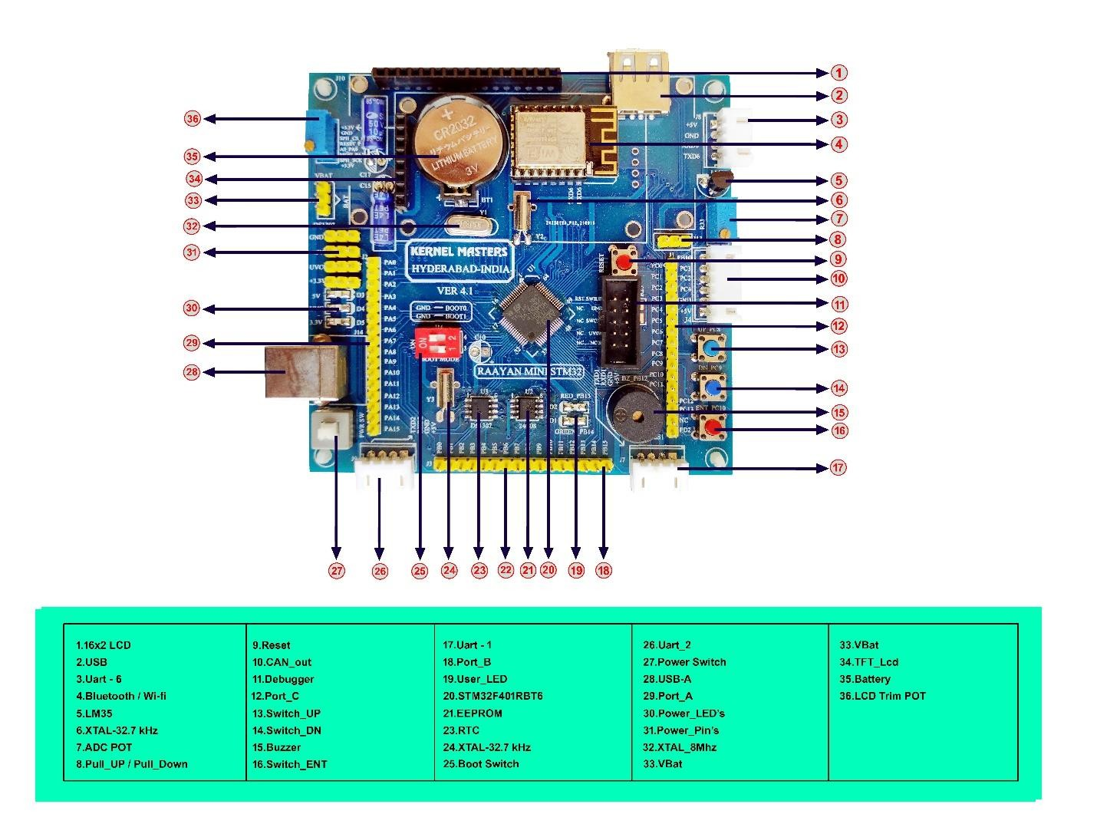

* 1. Kit Contents

The Raayan Mini STM32 Development Board Kit contains the following items:

* Raayan Mini Development Board (STM32F401RBTx)
* ST-Link Serial wire Debugger
* USB – TTL module
* USB Type A to B cable
* Jumper wires
* User manual
  1. Getting Started

Follow the sequence below to configure the Raayan Mini STM32F4 Development Board and launch application:

1. Check the switch positions of BOOT0, BOOT1 pins on the board.
2. Connect the STM32F4 Development board to a PC with a USB cable Type-A to B through USB connector J14 to power the board.
3. Press the push button SW5 (PWR SW). LEDs D3, D4, D5 then lights up.
4. The board runs a preloaded Board test application. The 16 X 2 LCD or the TFT display shows “Welcome to KM” followed by some test cases for testing the board and peripherals. Perform each test cases as shown in the display until all the peripherals are tested OK.
5. Discover the STM32F401RBT6 features and develop the application using available source code and libraries.
6. Connect the ST LINK to CN1 before flashing your application code to the microcontroller.
   1. Features

Your Raayan Mini Development board includes the following features:

* STM32F401RBT6 microcontroller featuring 32-bit Arm® Cortex®-M4 with FPU core, Up to 128-Kbytes of Flash memory and 64-Kbytes of RAM.
* On-board ST-LINK Serial wire debugger/programmer
* 5 LEDs:
  + 3 Power LEDs and 2 user LEDs
* On-board Buzzer
* 16 X 2 Monochrome LCD interface with GPIO
* TFT LCD interface with SPI
* DS1307 RTC interface with I2C
* AT24C02 EEPROM interface with I2C
* LM35 Temperature Sensor interface with ADC
* ESP Wi-Fi module interface with UART

USB Type A interface

* Flexible power-supply options: ST-LINK, USB Type B connector
* Expansion Headers supports,
* GPIO ports with interrupt capability
* I2C interface (1Mbit/s, SMBus/PMBus)
* Up to 3 USARTs (2 x 10.5 Mbit/s, 1 x 5.25 Mbit/s), ISO 7816 interface, LIN, IrDA, modem control)
* SPI interface (up to 42 Mbits/s at fCPU= 84 MHz), SPI2 and SPI3 with muxed full-duplex I2S to achieve audio class accuracy via internal audio PLL or external clock
* External application power supply: 3 V and 5 V
* Support of a wide choice of Integrated Development Environments (IDEs) including IAR Embedded Workbench®, MDK-ARM, and STM32CubeIDE.
  1. Specifications

Table 1-1 summarizes the specifications for the Raayan Mini STM32F4 Development Board.

**Table 1-1. Raayan Mini STM32F4 Development Board Specifications**

|  |  |
| --- | --- |
| **Parameter** | **Value** |
| Board supply voltage | 4.75 VDC to 5.25 VDC from USB Device Type A to B cable (connected to a PC) |
| Dimensions | (L x W x H) |
| Break-out power output | * 3.3 VDC (current rating) * 5.0 VDC (current rating) |
| RoHS status | Compliant |

* 1. Raayan Mini Pin diagram

**Figure 1-2. Raayan Mini STM32 Development Board Pin Diagram**

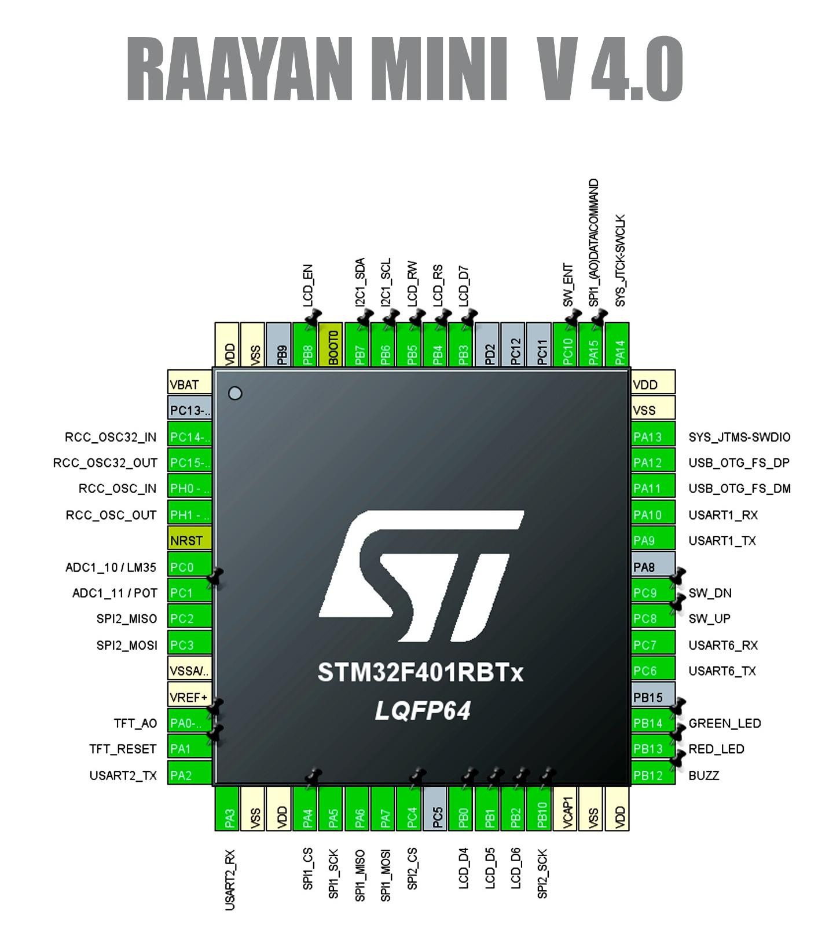

1. Hardware Description
   1. Raayan Mini Board Block Diagram

The Raayan Mini STM32F4 Development Board includes a STM32F401RBT6 microcontroller and a serial wire debugger as well as a range of useful peripheral features.

**Figure 2-1. Raayan Mini STM32F4 Development Board Block Diagram**

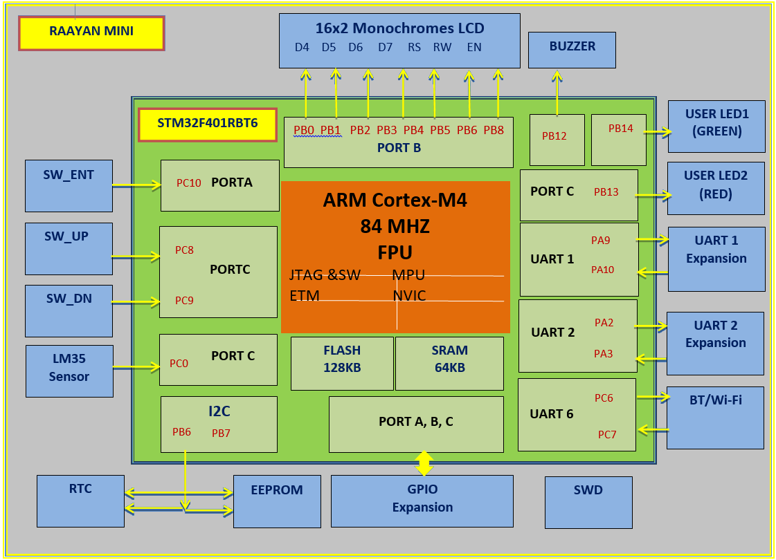

**JQ6500 16P**

* Electrical characteristics / Specifications
* Support all bit rates 11172-3 and ISO13813-3 layer3 audio decoding.
* The sampling rate support (KHZ): 8/11.025/12/16/22.05/24/32/44.1/48.
* Support sound effects like Normal, Jazz, Classic, Pop, Rock, etc.
* Input Voltage: power supply 3.5V-5V; optimum value 4.2V.
* Rated Current: 20mA.
* Size: Standard DIP16 package.
* Speaker Power: 8 ohm / 3 w.
* Operating Temperature: -40℃~80℃.
* Humidity: 5% ~ 95%.
* Pin description

SPK+

K1

16

15

9

J

Q

6

5

0

0

2

1

DC-5V

ADC-R

ADC-L

RX

TX

GND

BUSY

K5

SGND

K3

K2

SPK-

3

14

K4

13

4

12

5

11

6

ADKEY

10

7

8

* It has 16 pins
  + **K1** is the playback audio track1.
  + **K2** is the playback audio track2.
  + **K3** is the playback audio track3.
  + **K4** is the playback audio track4.
  + **K5** is the playback audio track5.
  + **SGND** is the ground pin.
  + **ADKEY** it the Button Control for **K1-K5**.
  + **BUSY** pin is the play indicator “high when audio o/p & low when no audio o/p.”
  + **RX** pin is the UART serial data input.
  + **TX** pin is the UART serial data output.
  + **GND** is the ground pin.
  + **DC** pin the power input for the module.
  + **ADC_R** right channel for the headphones or amplifier.
  + **ADC_L** left channel for the headphones or amplifier.
  + **SPK-** pin is for the speaker -ve terminal connection.
  + **SPK+** pin is for the speaker +ve terminal connection.
* Features
  + Supports sampling rate (KHz): 8/11.025/12/16/22.05/24/32/44.1/48.
  + 24-bit DAC output; dynamic range support 90dB; 85dB SNR support.
  + Supports FAT16, FAT32 file system, TF card (maximum capacity 32G), USB 32G, NORFLASH (64M bytes).
  + A variety of control modes: serial mode, AD button control mode.
  + Supports inter-cut announcement by pausing the ongoing background music.
  + Sort the audio data by folder; supports up to 100 folders with every folder assigned to 1000 songs.
  + 30 level volume adjustable, 10 EQ adjustable.
  + External spi flash if connected to the computer, can display spi flash drive to update the content.
  + Play the specific music through the Microcontroller serial.
* Software to upload audio files to the JQ6500.
  + JQ6500 Flash Tool (JQ6500 Programmer)
  + This is the official (or semi-official) software used to upload **.mp3** or **.wav** files to the module's flash memory.
* Download the Software:
* Search for "JQ6500 Flash Tool" online or download it from trusted sources like forums for electronics hobbyists (e.g., ElecFreaks or similar).
* Ensure it’s compatible with your operating system (usually Windows).
* Connect the Module
* Use a micro-USB cable to connect the JQ6500 to your computer.
* The module should be recognized as a USB device, usually marked as "JQ6500" or a similar name.
* Launch the Software
* Open the flash tool and verify the connection.
* You may need to select the device from a dropdown menu if multiple USB devices are connected.
* Upload Files
* Drag and drop your audio files into the interface.
* Ensure they are in supported formats like **.mp3** or **.wav**.
* Click **"Upload"** or **"Write"** to transfer the files to the module.

**Control Methods**

The mp3 module can be controlled in five methods, based on the particular application; the suitable method can be selected.

* Using push buttons, manual controlling can be done toward the ground like the K*, PL/PAUSE, NXT/PRV, SRC pins
* Manual control with the help of resistors and buttons toward the signal the action requested is throughout the ADKEY pin
* Limited control through Infrared remote and the device can recognize using remote control codes, mostly to play the five hot-key files
* Complete controlling can be done through an Arduino Library for the module. So this will give you control through some additional features like looping options, equalizer modes, direct access to several files over the SD Card, names of songs, etc.
* The complete controlling can be possible through a protocol like serial communication on TX/RX

**Circuit Diagram**

The **circuit diagram of the JQ6500 MP3 player** is shown below. This circuit is frequently called an MP3 player sound module or voice sound module. The name of the chip hosted on the module is JQ6500.

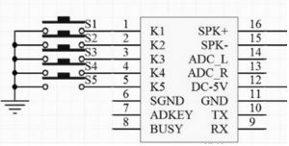

JQ6500 16P Module Circuit

The manufacturing of this chip can be done through a JQ company in China. On the other face of the printed circuit board, the module includes two extra integrated circuits like a 25L1606E (a flash memory with 16Mbit & HXJ 8002 & an audio amplifier with 3W.

Once this module is connected to the computer through USB then it is noticed like a CDROM drive. While browsing content for the CD, we can discover the application for MusicDownload.exe. This application mainly permits to upload of audio files within the flash memory

The controlling of the JQ6500 chip can be done in several ways but the simplest one is through outside buttons which are connected toward pins K1 to K5

Once you push a button from K1 to K5, then the module plays the equivalent audio file. For instance, if you push the connected button to the K1 pin, the module plays the 001.mp3 audio file.

The onboard amplifier like HXJ 8002 is a mono chip & its output can be allied to both the pins like SPK+ & SPK-. Thus, these pins can be connected to a speaker. If you need stereo audio, then you can use pins like ADC_R & ADL_L & connect them to an exterior amplifier.

So finally this mp3 module is an inexpensive & outstanding solution to include audio in your security-based projects. The internal flash memory is very useful because there is no requirement for SD cards to store different audio files.

**COMMANDS:**

The device (appears to) accepts commands at any time.  Commands consist of 4 or more bytes,

1. Each command starts with byte 0x7E
2. Followed by a byte indicating the number of  bytes which follow including the terminating byte (including termination)
3. Followed by a byte indicating the command to execute
4. Followed by an optional first argument byte
5. Followed by an optional second argument byte
6. Followed by the byte  0xEF as the termination byte

for example, the command ”PLAY” (0x0D) is constructed with the following 4 bytes

1. **0x7E** – Start Byte
2. **0x02** – 2 Bytes Follow
3. **0x0D** – Command Byte
4. **0xEF** – Termination Byte

and the command  to play a specific file (0x012) has two arguments (folder number and file number) so it looks like this

1. **0x7E** – Start
2. **0x04** – 4 Bytes Follow
3. **0x12** – Command
4. **0x02** – 1st Argument  (in this case,  “Folder 02”)
5. **0x03** – 2nd Argument (in this case,  “File 003”)
6. **0xEF** – Termination Byte

**Control Commands**

* **0x0D – Play**, No Arguments
* **0x0E – Pause**, No Arguments
* **0x01 – Next**, No Arguments
* **0x02 – Prev**, No Arguments
* **0x03 – Play file by index number**, 2 Arguments.  The index number being the index in the FAT table, or upload order.  Argument 1 = high 8 bits of index number, Argument 2 = low 8 bits of index number.
* **0x0F – Change folder**. 1 Argument.  Argument 1 = 0x01 for Next Folder, 0x00 for Previous Folder.
* **0x12 – Play file by folder and name**, 2 Arguments.  This applies to SD Card only where you have folders named 01 through 99, and files in those folders named 001.mp3 through 999.mp3.  Argument 1 = folder number, Argument 2 = file number.  Note that arguments are a single byte, so effectively I think you can only access up to file 255.mp3 in any folder.
* **0x04 – Vol Up**, No Arguments
* **0x05 – Vol Dn**, No Arguments
* **0x06 – Set Volume**, 1 Argument.  Argument 1 = byte value from 0 to 30
* **0x07 – Set Equalizer Mode**, 1 Argument.  Argument 1 = byte value 0/1/2/3/4/5 for Normal/Pop/Rock/Jazz/Classic/Bass (actually  “Base” in the datasheet but I think they mean Bass)
* **0x11 – Set Loop Mode**, 1 Argument.  Argument 1 = byte value  0/1/2/3/4 for All/Folder/One/Ram/One_Stop – I don’t know what  “Ram” is, it’s not Random, it seems the same as  “One”.
* **0x09 – Set the source**, 1 Argument.  Argument 1 = 0x01 for SDCard and 0x04 for the on board flash memory.
* **0x0A – Sleep** mode, No Arguments.  Supposedly a low power mode.
* **0x0C – Reset**, No Arguments.  It’s advisable to wait 500mS or so after issuing this.

**IR Sensor**

IR sensor is an electronic device that emits the light to sense some object of the surroundings. An IR sensor can measure the heat of an object as well as detect the motion. Usually, in the infrared spectrum, all the objects radiate some form of thermal radiation. These types of radiation are invisible to our eyes, but infrared sensors can detect these radiations. The emitter is simply an IR LED (Light Emitting Diode) and the detector is simply an IR photodiode . Photodiode is sensitive to IR light of the same wavelength which is emitted by the IR LED. When IR light falls on the photodiode, the resistances and the output voltages will change in proportion to the magnitude of the IR light received.

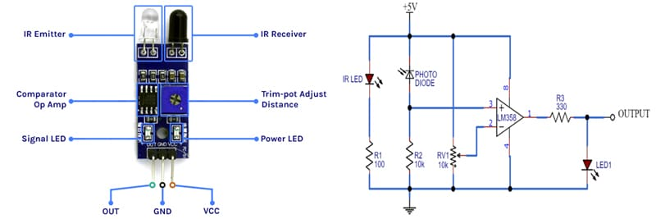

**IR Sensor**

* **Working principle**

There are different types of infrared transmitters depending on their wavelengths, output power and response time. An IR sensor consists of an IR LED and an IR Photodiode, together they are called PhotoCoupler or OptoCoupler.

**IR Transmitter or IR LED**

Infrared Transmitter is a light emitting diode (LED) which emits infrared radiation called IR LED’s. Even though an IR LED looks like a normal LED, the radiation emitted by it is invisible to the human eye.

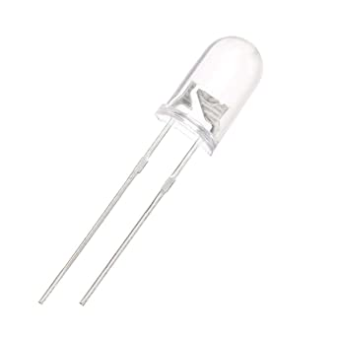

**Infrared LED**

**IR Receiver or Photodiode**

Infrared receivers or infrared sensors detect the radiation from an IR transmitter. IR receivers come in the form of photodiodes and phototransistors. Infrared Photodiodes are different from normal photo diodes as they detect only infrared radiation.

**IR receiver or a photodiode**

* **Operation**

An IR sensor can detect changes in the amount of infrared radiation impinging upon it, which varies depending on the temperature and surface characteristics of the objects in front of the sensor. When an object, such as a person, passes in front of the background, such as a wall, the temperature at that point in the sensor's field of view will rise from room temperature to body temperature, and then back again. The sensor converts the resulting change in the incoming infrared radiation into a change in the output voltage, and this triggers the detection. Objects of similar temperature but different surface characteristics may also have a different infrared emission pattern, and thus moving them with respect to the background may trigger the detector as well. IRs come in many configurations for a wide variety of applications. The most common models have numerous Fresnel lenses or mirror segments, an effective range of about 10 meters (30 feet), and a field of view less than 180°. Models with wider fields of view, including 360°, are available, typically designed to mount on a ceiling. Some larger IRs are made with single segment mirrors and can sense changes in infrared energy over 30 meters (100 feet) from the IR. There are also PIRs designed with reversible orientation mirrors which allow either broad coverage (110° wide) or very narrow "curtain" coverage, or with individually selectable segments to "shape" the coverage.

* **Differential detection**

Pairs of sensor elements may be wired as opposite inputs to a differential amplifier. In such a configuration, the IR measurements cancel each other so that the average temperature of the field of view is removed from the electrical signal; an increase of IR energy across the entire sensor is self-cancelling and will not trigger the device. This allows the device to resist false indications of change in the event of being exposed to brief flashes of light or field-wide illumination. (Continuous high energy exposure may still be able to saturate the sensor materials and render the sensor unable to register further information.) At the same time, this differential arrangement minimizes common-mode interference, allowing the device to resist triggering due to nearby electric fields. However, a differential pair of sensors cannot measure temperature in this configuration, and therefore it is only useful for motion detection.

* **Implementation**

When an IR sensor is configured in a differential mode, it specifically becomes applicable as a motion detector device. In this mode, when a movement is detected within the "line of sight" of the sensor, a pair of complementary pulses are processed at the output pin of the sensor. To implement this output signal for a practical triggering of a load such as a relay or a data logger, or an alarm, the differential signal is rectified using a bridge rectifier and fed to a transistorized relay driver circuit. The contacts of this relay close and open in response to the signals from the IR, activating the attached load across its contacts, acknowledging the detection of a person within the predetermined restricted area.

* **Advantages**
* It uses less power.
* The detection of motion is possible in the presence or absence of light approximately with equal reliability.
* They do not need contact with the object for detection.
* There is no data leakage because of the ray direction.
* These sensors are not affected by oxidation & corrosion.
* Noise immunity is very strong.
* **Applications**
* Security.
* Maintenance.
* Industrial safety.
* Automatic lighting.
* Home-based assisted living.
* Smart home and IoT.

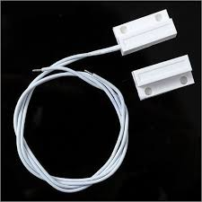**Reed Sensor**

REED SENSOR

* **Operation**

A reed sensor operates by the magnetic actuation of two ferromagnetic reeds sealed within a glass envelope. In the absence of a magnetic field, the reeds remain in their default state, either separated (normally open) or in contact (normally closed). When a magnetic field is introduced, the reeds are magnetized, causing them to either attract and close the circuit (for normally open configurations) or repel and open the circuit (for normally closed configurations).

Once the magnetic field is removed, the mechanical spring force of the reeds restores them to their original state. The sensor is sensitive to the strength, orientation, and distance of the magnetic field, enabling reliable switching for applications like proximity sensing, position detection, and security systems.

* **Working principle**

The working principle of a reed sensor relies on the interaction between magnetic fields and ferromagnetic materials. Inside the sensor, two thin, flexible reeds made of a ferromagnetic material, such as nickel-iron, are enclosed within a hermetically sealed glass tube. These reeds act as electrical contacts and are positioned either in a normally open (NO) or normally closed (NC) configuration. When a magnetic field is applied near the sensor, the magnetic flux lines induce opposite magnetic poles on the reeds. In an NO configuration, this causes the reeds to attract each other and close the circuit, allowing current to flow. In an NC configuration, the magnetic field forces the reeds apart, breaking the circuit and stopping the current flow. Once the magnetic field is removed, the mechanical spring force inherent in the reeds restores them to their default state, either open or closed.

The sensor's operation depends on specific magnetic field characteristics, such as strength, orientation, and proximity. A threshold magnetic field strength, known as the pull-in field, is required to actuate the reeds, while a weaker drop-out field ensures they return to their default state when the magnetic influence is removed. This hysteresis effect prevents rapid oscillations (chattering) at the actuation threshold, ensuring stable operation. The simplicity, reliability, and ability to operate without power make reed sensors widely used in applications like proximity sensing, security systems, flow meters, and automotive position detection.

* **Advantages**
* No Power Required for Switching: Operates passively using an external magnet.
* Isolation of Contacts: Glass encapsulation ensures durability and operation in harsh environments.
* Versatile: Used in both analog and digital circuits.
* **Applications**

**Door/Window Sensors:**

* Magnet attached to the moving part (door/window), sensor on the fixed part.
* Sensor activates when the door/window opens, breaking the alignment with the magnet.

**Flow Measurement:**

* Reed sensors detect the rotation of a paddlewheel with embedded magnets, translating to flow rate.

**Position Sensing:**

* Detects the presence or position of a magnetic actuator in assembly lines or robotics.

**PROTOCOL USED: UART**

UART (Universal Asynchronous Receiver/Transmitter) is a communication protocol used for serial communication, where data is transmitted bit by bit over a single wire or pair of wires for full-duplex communication. UART is widely used for communication between microcontrollers, computers, sensors, and other digital devices.

**UART Features**

* **Asynchronous**: UART doesn't require a clock signal for synchronization. Instead, the sender and receiver use pre-configured baud rates to maintain synchronization. The baud rate must be the same on both ends for reliable communication.
* **Full-Duplex Communication**: UART can send and receive data simultaneously, using two separate lines—one for transmission (TX) and one for reception (RX).
* Two wire communication protocol(including ground 3 wires)
* Configurable oversampling method by 16 or by 8 to give flexibility between speed and clock tolerance
* Programmable data word length (8 or 9 bits)
* Fractional baud rate generator systems– Common programmable transmit and receive baud rate
* Configurable stop bits - support for 1 or 2 stop bits
* Separate enable bits for transmitter and receiver

**UART Frame Structure**

The data transmitted in UART consists of frames, with each frame having the following structure:

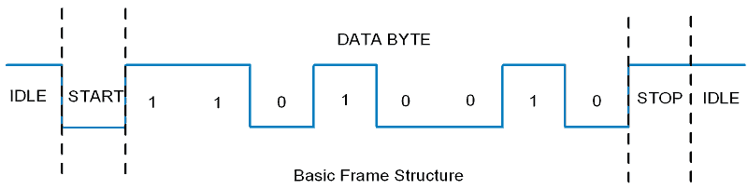

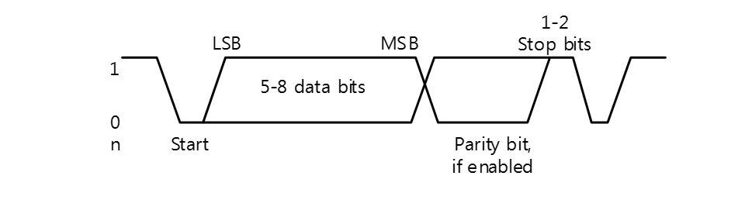

1. Start Bit (1 bit):
   * Marks the beginning of data transmission. It is usually a "low" signal (0).
2. Data Bits (5 to 9 bits, typically 8 bits):
   * The actual data being transmitted. The number of data bits can be set to 5, 6, 7, or 8 bits, with 8 bits being most common.
3. Parity Bit (optional, 1 bit):
   * Even parity, Odd parity or No parity:
4. Stop Bits (1 to 2 bits, typically 1 bit):
   * Marks the end of the frame. Stop bits can be 1, 1.5, or 2 bits, with 1 bit being the most common.

**Baud rate:**

1. 9600(baud rate) 8(word length) N(No parity) 1(stop bits)

No. of bits = 1+8+0+1 = 10 bits

1. 115200 5 E 2

No. of bits = 1+5+1+2=9 bits

2. 34600 7 O 1

No. of bits = 1+7+1+1=10 bits

**ADC:**

An analog to digital converter is a digital circuit designed to perform conversion of analog signals into digital data format. It is also known ADC. Analog to digital converters are essential components in digital systems like computers, data processors, digital communication systems, etc.

The following figure depicts the **block diagram of an analog to digital converter** −

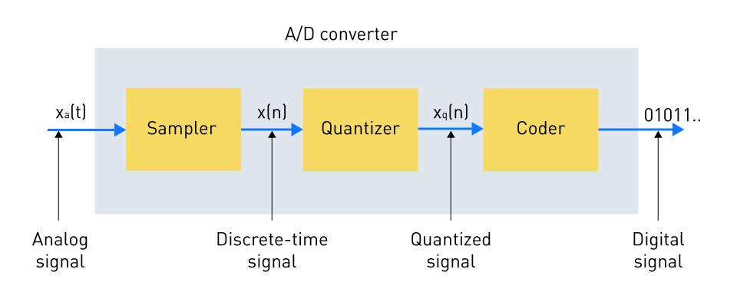

From this figure, it is clear that the input to an analog to digital converter is an analog or natural signal and the output is a digital or discrete time signal.

In practical systems, the analog to digital converter serves as an interface between external environment and a digital system.

**Working of Analog to Digital Converter**

The working of an analog to digital converter involves the processes explained below −

**Inputting Analog Signal**

An analog to digital converter takes an analog signal as input. The analog signal could be a voltage, current, temperature, pressure, or any other physical quantity that changes continuously with time.

**Sampling**

At this stage, the analog to digital converter samples the input analog signal at regular intervals of time. These time intervals are defined in terms of sampling rate.

In the sampling process, the analog signal that varies continuously over time is measured at discrete instants of time to collect discrete values of the signal.

**Quantization**

Quantization is a process of assigning a digital or discrete value to each sampled value of the analog signal. In the process of quantization, the range of all possible analog values is divided into a finite number of discrete digital values.

**Encoding**

Encoding is a process of converting the quantized digital values into their equivalent binary numbers. These encoded binary numbers represent the sampled analog values in the digital format.

The resolution, accuracy, and precision of the analog to digital converter is determined by the number of bits used for encoding.

**Outputting Digital Signal**

At the end, the analog to digital converter produces a digital signal as output. This output digital signal can be processed, stored, or transmitted by digital systems.

**Performance Factors of Analog to Digital Converters**

The performance of an analog to digital converter can be evaluated using several different factors. The following two are the most important −

**Signal-to-Noise Ratio (SNR) of ADC**

The Signal-to-Noise Ratio (SNR) of an analog to digital converter is defined as the measure of ability of the converter to differentiate between the desired signal and unwanted noise signal.

Mathematically, the SNR of an analog to digital converter is expressed as the ratio of the power of the electrical signal (that represents the useful information) to the power of the noise signal (that represents the unwanted disturbances).

In practice, the SNR is expressed in decibels (dB) and the formula for calculating the SNR of an ADC is given below,

SNRofADC=10×log(ElectricalSignalPowerNoiseSignalPower)SNRofADC=10×log(ElectricalSignalPowerNoiseSignalPower)

From this expression, it is clear that a higher SNR represents better performance of the analog to digital converter. In other words, an analog to digital converter having a high SNR distinguishes the electrical signal from the noise signal more clearly. Therefore, it is desirable that the analog to digital converter have a high SNR so that it can accurately capture and digitalize smaller analog signals even in the presence of noise signals.

**Bandwidth of Analog to Digital Converter**

The bandwidth of an analog to digital converter is nothing but the range of frequencies that it can sample and digitalize accurately. The sampling rate of the analog to digital converter determines its bandwidth. Where, the sampling rate is defined as the number of samples of the analog signal taken per second.

According to the Nyquist-Shannon sampling theorem, the maximum sampling rate of an analog to digital converter should be at least double of the maximum frequency component present in the input analog signal. It is an important factor to avoid misidentification of the signal that can introduce distortion or error in sampling.

Let us take an example to understand this, consider an analog to digital converter having a maximum sampling rate of 150 kHz, then its bandwidth should be limited to frequencies less than 75 kHz to prevent distortion.

Hence, it is important that the analog to digital converter should have a sufficient bandwidth to capture the high-frequency analog signals accurately.

**DAC:**

A DAC (Digital-to-Analog Converter) is an electronic device that converts digital data (usually binary) into an analog signal. This process is essential because many real-world devices, such as speakers, displays, and motors, operate using analog signals, while modern devices like computers, smartphones, and digital audio players work in the digital domain.

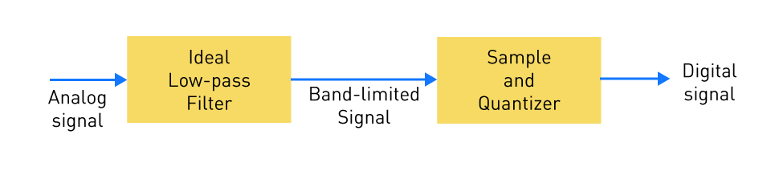

Key Features of a DAC:

1. Input: The input to a DAC is typically a binary number, often represented as a series of 1s and 0s (digital data). This digital signal can come from various sources like microcontrollers, computers, or audio systems.
2. Output: The DAC generates an analog signal corresponding to the digital input. For example, in audio systems, it converts the digital audio file into an analog waveform that can drive speakers or headphones.
3. Resolution: The resolution of a DAC determines how finely it can represent analog values. It is typically measured in bits. A higher resolution means a more precise and smoother output. For example, an 8-bit DAC can represent 256 discrete output levels, while a 16-bit DAC can represent 65,536 levels.
4. Sampling Rate: The sampling rate refers to how frequently the DAC updates the output. In audio applications, this is often measured in samples per second (e.g., 44.1 kHz, which is the standard for CD audio).
5. Accuracy: The accuracy of the DAC is critical for applications requiring precise signal reproduction, such as high-fidelity audio systems.

Applications of DAC:

* Audio Systems: Converting digital audio files into an analog signal for speakers or headphones.
* Video Systems: Converting digital video data to analog signals for older TVs or monitors.
* Communication Systems: Used in modems and other devices that require signal conversion.
* Signal Processing: Converting digitally processed signals into analog form for various measurement or control purposes.

Example:

In an audio player: The player stores digital audio files, which are decoded and sent to the DAC. The DAC then converts the digital data into an analog waveform, which is sent to an amplifier. The amplifier powers the speakers, producing sound.

**Sampling Theorem Statement**

In precise terms, if x(t) is a continuous-time signal with bandwidth W, it can be reconstructed from its samples x(nTs) where Ts is the sampling period. The samples must be taken at a rate Fs = 1/Ts which satisfies the Nyquist sampling criterion:

**Fs > 2W**

Or equivalently,

**Ts < 1⁄2W**

Where W is the highest frequency of the signal x(t). This statement forms the foundation of digital signal processing and underlines the core principle of sampling theory.

A continuous-time signal can be represented by its samples and recovered if the sampling frequency (fs) is at least twice the highest frequency component of the message signal.

fs≥2fm

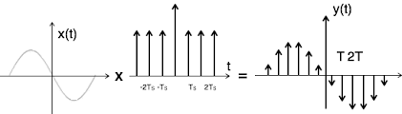

**QUANTIZATION:**

The digitization of analog signals involves the rounding off of the values which are approximately equal to the analog values. The method of sampling chooses a few points on the analog signal and then these points are joined to round off the value to a near stabilized value. Such a process is called as **Quantization**.

Quantizing an Analog Signal

The analog-to-digital converters perform this type of function to create a series of digital values out of the given analog signal. The following figure represents an analog signal. This signal to get converted into digital, has to undergo sampling and quantizing.

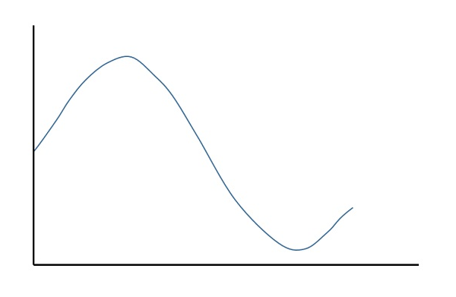

The quantizing of an analog signal is done by discretizing the signal with a number of quantization levels. **Quantization** is representing the sampled values of the amplitude by a finite set of levels, which means converting a continuous-amplitude sample into a discrete-time signal.

The following figure shows how an analog signal gets quantized. The blue line represents analog signal while the brown one represents the quantized signal.

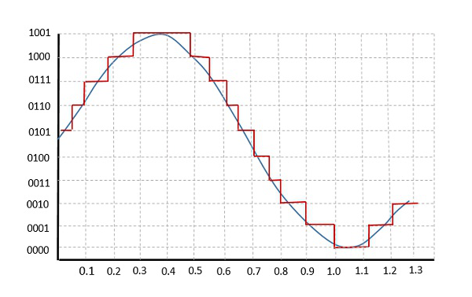

Both sampling and quantization result in the loss of information. The quality of a Quantizer output depends upon the number of quantization levels used. The discrete amplitudes of the quantized output are called as **representation levels** or **reconstruction levels**. The spacing between the two adjacent representation levels is called a **quantum** or **step-size**.

The following figure shows the resultant quantized signal which is the digital form for the given analog signal.

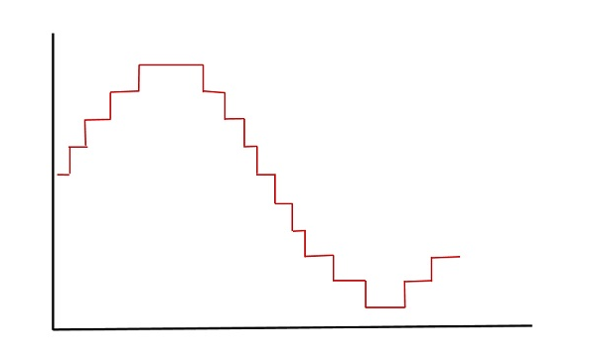

This is also called as **Stair-case** waveform, in accordance with its shape.

**ENCODING**:

Encoding is the process of turning thoughts into communication by selecting words, symbols, or pictures to represent a message. The goal of encoding is to create a message that the receiver can easily understand.

**PWM (Pulse Width Modulation)** is a technique used to control the amount of power delivered to an electrical load by varying the width (duration) of pulses in a signal, while keeping the frequency constant.

**Key Features:**

1. **Duty Cycle**: This is the ratio of the pulse "on" time to the total period of the waveform. It is expressed as a percentage. For example:
   * 50% duty cycle means the pulse is "on" for half the period and "off" for the other half.
   * A 100% duty cycle means the signal is continuously "on" without any "off" time.
2. **Frequency**: The frequency of the PWM signal determines how fast the pulses repeat. A higher frequency can make the output appear smoother, while a lower frequency might create a more noticeable, flickering effect in applications like lighting.
3. **Applications**:
   * **Motor control**: Adjusting the speed of motors by varying the duty cycle.
   * **LED dimming**: Adjusting the brightness of LEDs by changing the duty cycle.
   * **Power regulation**: In power supplies and DC-DC converters, where voltage regulation is needed.
   * **Signal processing**: PWM can be used in analog-to-digital conversion processes or other forms of signal modulation.
4. **Advantages**:
   * **Efficiency**: Since the switch is either fully on or fully off, there's minimal power lost in the switch, making PWM an efficient way to control power.
   * **Precision**: The amount of power is precisely controlled by adjusting the duty cycle.

**Example:**

* If you use PWM to control the speed of a DC motor, at 100% duty cycle, the motor runs at full speed. At 50% duty cycle, the motor would run at half speed, as it receives power only half of the time.

**HOW DIGITAL DATA CAN BE CONVERTED INTO ANALOG BY USING PWM**

To convert **digital data** into **analog** using **PWM (Pulse Width Modulation)**, the process involves modulating the duty cycle of the PWM signal in a way that represents the desired analog signal. This can be achieved by following a few key steps:

**Steps for Conversion from Digital to Analog using PWM:**

1. **Digital Data Representation**: The digital data, which is typically in the form of binary numbers (such as 8-bit, 16-bit values, etc.), needs to be mapped into a range of analog voltages. This digital data could represent sensor readings, audio signals, or any form of data that requires analog conversion.
2. **PWM Generation**: The PWM signal is generated with a frequency (usually a high frequency, like 1 kHz to several MHz), and the duty cycle of the PWM signal is varied according to the value of the digital data. A higher duty cycle represents a higher analog value, and a lower duty cycle represents a lower analog value.
   * For example, if the digital data is an 8-bit value, it can range from 0 to 255. A digital value of 255 would correspond to a 100% duty cycle, and a digital value of 0 would correspond to a 0% duty cycle.
3. **Low-Pass Filtering**: To convert the discrete PWM signal into a smooth analog signal, a **low-pass filter** (usually a simple resistor-capacitor (RC) circuit) is used. The low-pass filter smoothes out the rapid switching of the PWM signal, effectively averaging the high-frequency components and leaving only the desired analog signal.
   * For example, when a PWM signal with a duty cycle of 50% is passed through a low-pass filter, the result will be an average voltage that is half of the maximum voltage, effectively producing an analog output of 50% of the maximum.
4. **Analog Signal Output**: The output of the low-pass filter is a smooth, varying voltage that represents the analog version of the original digital data. The voltage level corresponds to the duty cycle of the PWM signal.
   * If the PWM signal had a 25% duty cycle, the resulting analog voltage after filtering would be 25% of the maximum voltage.
   * A 75% duty cycle would result in 75% of the maximum voltage.

**Example:**

Consider you want to convert a digital value (for example, from an ADC or a digital sensor) into an analog voltage:

* **Digital data**: Let’s say you receive a value of 128 (out of a possible 255).
* **PWM duty cycle**: The duty cycle would be (128 / 255) * 100 ≈ 50%.
* **PWM signal**: A PWM signal with a 50% duty cycle will be generated.
* **Low-pass filter**: A low-pass filter (e.g., an RC filter) smooths out the PWM signal.
* **Analog output**: The result will be an analog voltage that represents approximately 50% of the maximum voltage.

**Why PWM Works for Digital to Analog Conversion:**

* **PWM's Precision**: By changing the duty cycle of the PWM signal, you can precisely control the average voltage delivered to a load, which mimics the behavior of an analog signal.
* **Simplicity**: The technique is simple, efficient, and requires fewer components (like just a filter), making it very suitable for embedded systems and low-cost designs.

**Applications:**

* **Audio Signals**: In audio amplifiers, digital audio data can be converted to an analog waveform using PWM.
* **Dimming LEDs**: The brightness of an LED can be adjusted based on the PWM duty cycle, effectively simulating an analog dimming control.
* **Motor Speed Control**: The speed of a DC motor can be controlled by adjusting the duty cycle of the PWM signal, which is derived from digital data inputs.

In summary, by adjusting the duty cycle of the PWM signal according to the digital data, and then filtering out the high-frequency components, you can effectively convert digital data into a smooth analog voltage.

**HOW THESE ARE RELATED TO OUR PROJECT?**

Our JQ6500 module main working depends on the DAC but we have little idea on ADC also.

The **JQ6500** does not **convert audio files to digital files**, but rather **plays digital audio files** stored on a memory card (such as a **microSD card**) or flash and **converts** those digital files into analog audio signals. Here’s a more detailed explanation of the process, focusing on how the JQ6500 handles digital audio files:

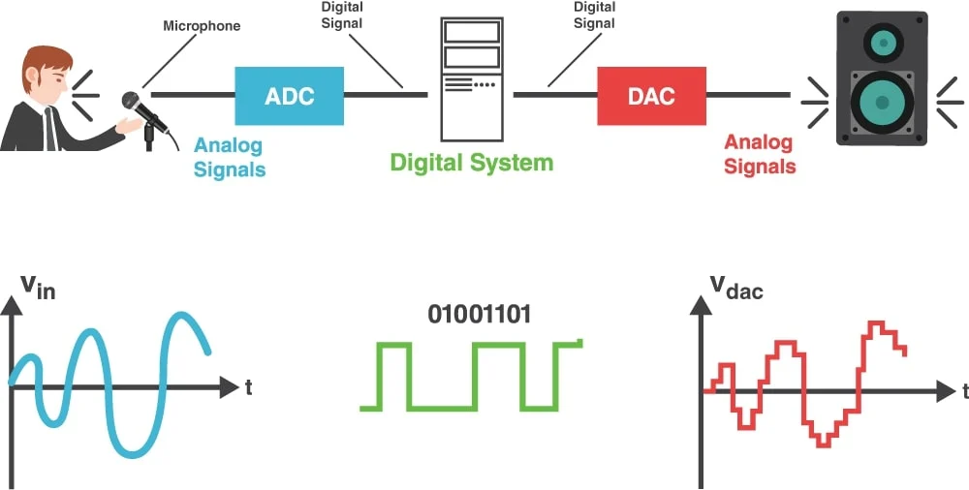

**Process of Audio Playback in the JQ6500:**

1. **Storage of Audio Files (Digital Format)**:
   * The JQ6500 stores audio files (like **WAV**, **MP3**, or other formats) on a **microSD card** or **internal flash memory**.
   * These files are already **digital** (i.e., they are stored as sequences of binary data that represent the audio information).
2. **Decoding the Digital Audio**:
   * When you play a file, the JQ6500 **reads** the digital data (such as a WAV or MP3 file) from the microSD card or memory.
   * If the file is in MP3 format, for instance, the JQ6500 will **decode** the MP3 file into a **pulse-code modulation (PCM)** format (this is a standard uncompressed digital format).
     + PCM is a representation of the audio in a digital form that represents the waveform of the sound at discrete points in time.
3. **Digital-to-Analog Conversion (DAC)**:
   * Once the JQ6500 has decoded the file into a digital PCM format (if needed), it passes this data to its **built-in Digital-to-Analog Converter (DAC)**.
   * The DAC converts the **digital audio data** (the PCM signal) into an **analog signal**. This analog signal is a continuous waveform that can be used to drive speakers.
     + **Digital Audio** (e.g., PCM) has discrete values, while **Analog Audio** is a continuous signal.
4. **Amplification and Output**:
   * The analog signal generated by the DAC is then output through the audio pins (such as a **line-out** or **headphone jack**).
   * The analog signal may then be sent to an external amplifier to drive a speaker, or directly to a speaker if the system is designed to amplify the signal on-board.

**HOW WE ARE SENDING COMMANDS TO JQ6500 16P?**

To control the **JQ6500** audio module, you send commands to it via either **UART (serial communication)** or **GPIO (general-purpose input/output) pins**. The most common method is using **UART** for more flexibility and ease of control, as it allows you to send commands from a microcontroller, computer, or any system with a UART interface.

**Methods to Send Commands to the JQ6500**

**1. Using UART (Serial Communication)**

* **UART** allows you to send serial data to the JQ6500 from a microcontroller (e.g., Arduino, Raspberry Pi, etc.), a PC, or any other device with a UART interface.
* The JQ6500 expects specific **command sequences** to control functions like play, pause, stop, skip, or volume control.

**Steps to send commands via UART:**

1. **Connect the JQ6500 to a microcontroller or UART device**:
   * **TX (Transmit)** pin of the microcontroller goes to the **RX (Receive)** pin of the JQ6500.
   * **RX (Receive)** pin of the microcontroller goes to the **TX (Transmit)** pin of the JQ6500.
   * **Ground** (GND) of the microcontroller and the JQ6500 must be connected.
2. **Set the Baud Rate**:
   * Set the **UART baud rate** for communication. The default baud rate for the JQ6500 is typically **9600** bps (bits per second).
   * Ensure that both the sending device (e.g., Arduino) and the JQ6500 are set to the same baud rate.
3. **Send Commands via Serial**:
   * You need to send specific commands in the correct format over UART to control the module. The JQ6500 expects a specific protocol to operate.
   * **Example Command**: To play a specific audio file:
     + Command Format: **0x7E, 0xFF, 0x06, 0x01, 0x00, 0x00, 0x00, 0x00, 0x7E**
     + This command would instruct the JQ6500 to start playing a specific file, depending on the parameters you send.
4. **Command Structure**:
   * The commands usually follow a structure:
     + **Start Byte (0x7E)**: Marks the beginning of the command sequence.
     + **Command Byte**: Indicates the action (e.g., play, pause, stop).
     + **Data Bytes**: Contain specific parameters like the file index or volume level.
     + **End Byte (0x7E)**: Marks the end of the command sequence.
   * The **command bytes** and **data bytes** vary depending on what action you want to perform. Each action corresponds to a different **command byte**.

**Example Commands:**

Here are a few common commands:

* **Play a file** (index 0):
  + **Command**: 7E 02 0D EF
  + This will play the first file stored in the memory (index 0).
* **Pause playback**:
  + **Command**: 7E 02 0E EF
  + This will pause the current playback.
* **Stop playback**:
  + **Command**:7E 03 11 00 EF
  + This will stop the audio playback.
* **Volume control**:
  + **Command**: 7E 03 06 15 EF
  + You can adjust the **Volume** parameter (e.g., Volume = 0x10 for volume level 16).

**2. Using a Button Interface**

* In many consumer or embedded applications, the JQ6500 can be controlled using physical buttons that are connected to the GPIO pins. Each button sends a specific command to the chip, such as:
  + **Next/Previous track**.
  + **Play/Pause**.
  + **Stop**.
  + **Volume adjustment**.